Public Address (PA) System 4 Zone Mixer Amplifier with Bluetooth
FA-460M/FA-4150M/FA-4280M/FA-4480M/FA-4650M/FA-4850M
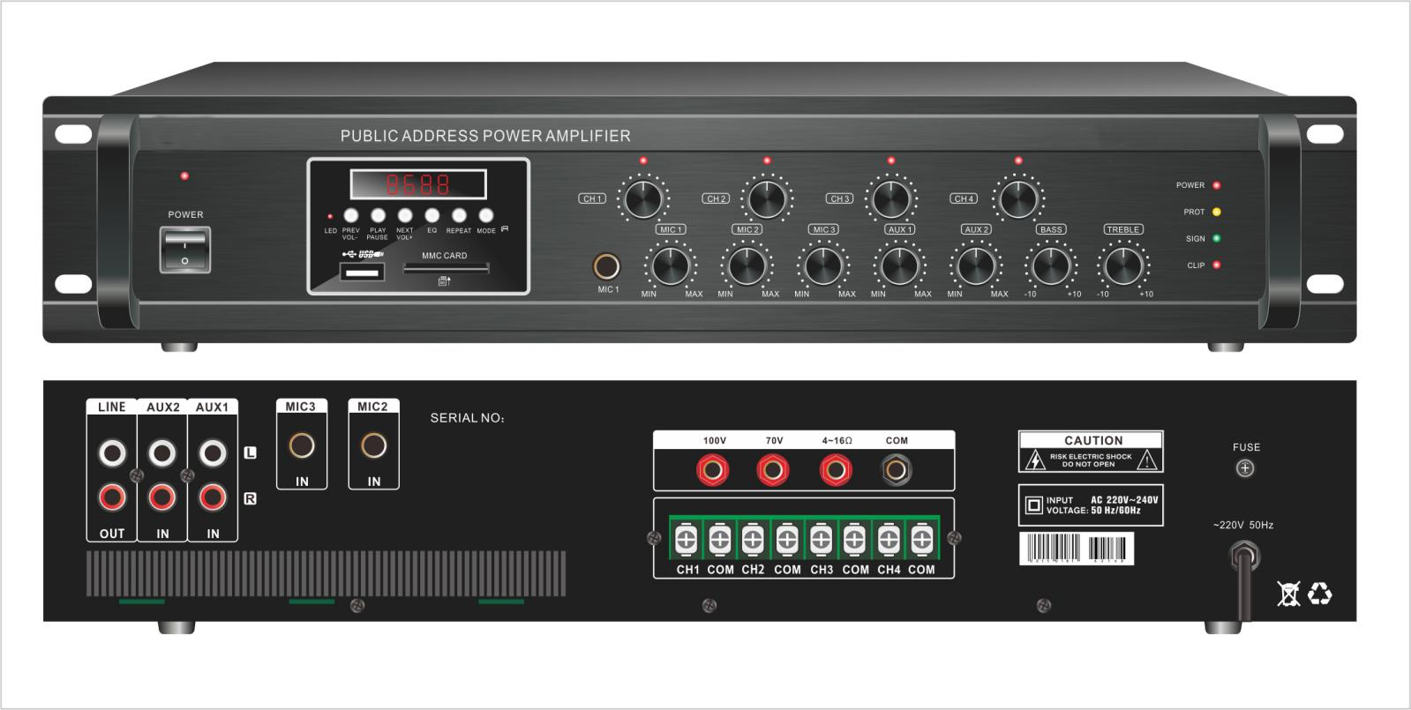

Description:

The PA 4 Zone Mixer Amplifier with MP3 and FM /SD/Bluetooth, its rated power output from 60W, 150W, 280W, 480W to 850W,
it is ideal for school, super market, bank, hotel BGM and speech use. It is all in one solution with two sources, preamplifier and mixer power amplifier into one 19” 2U height unit, which is economy but of high reliable performance.

The amplifier is with 3 MIC and two line input. Mic1 VOX with highest priority except EMC input. One USB and one SD slots on front provide easy access and operation for installer and end-user.

The amplifier is design with complete protection of overload, short circuit and high temp to avoid any damage.

These amplifiers are suitable for applications in bank, mosque, school, hotel, restaurant, theme centers and shopping center.

Features:
- Public address (PA) 4 zone commercial mixer power amplifier.
- 19” rack mount amplifier of 2U height.
- Rated outputs of 60W, 150W, 280W, 480W to850W.
- 4 zone speaker outputs of 100V or 70V and 8ohms
- Four zone speaker outputs with independent volume control.
- Built-in MP3 player by USB & SD and FM tuner and Blue tooth
- Three microphone inputs, Mic1(6.3mm) in front panel and MIC2-3 on rear panel
- Line 1-2 inputs on rear panel by RCA.
- Microphone1 of VOX features of highest input priority.
- Volume control for Mic1-3 and line 1-2, bass & treble and zone volume control on front panel.
- Overload, short circuit and high temp protection.

Public Address (PA) System 4 Zone Mixer Amplifier with Bluetooth
FA-460M/FA-4150M/FA-4280M/FA-4480M/FA-4650M/FA-4850M

Rear Panel:
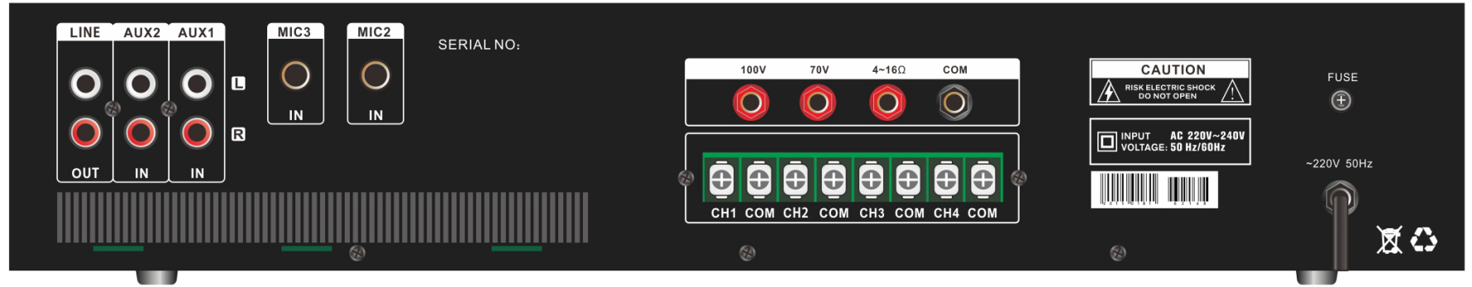

Specification:

Model | FA-460M | FA-4150M | FA-4280M | FA-4480M | FA-4850M
Description | Public Address System 60W Mixer Amplifier
Rated Power Output | 60W | 150w | 280w | 480w | 850w
Speaker Output | 70V, 100Vand 8ohms, 4zone speaker out 100V
Input | Mic1-3: 600 ohms(Ω) 5-8 mV, unbalanced, Line1-2: 10k ohms(Ω) 150-470 mV,  unbalanced
Frequency Response | 60-15KHz
THD | <0.5% at 1kHz, 1/3 rated power
S/N Ratio | Line: 85 dB , MIC: >72 dB
Protection | High temp, short circuit, overload protection
Power Supply | AC230V or AC110V, 50-60Hz
Power Consumption | 100W | 200W | 400W | 650W | 1000W
Dimension | 418(W)×318(D)×88(H)mm
Gross Weight | 7.5kg | 9.5kg | 12.2kg | 16kg | 17.6kg
Warranty | 3 years

